

APPLICATION FOR ADMISSION
CUCA ID NUMBER:

PLEASE HIGHLIGHT/CHECK YOUR PREFERENCES

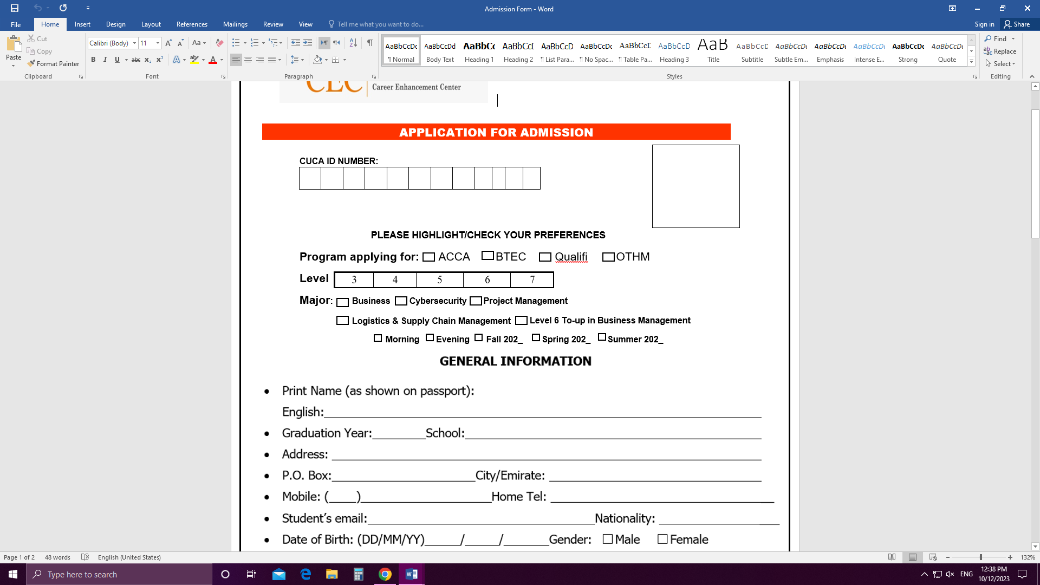

GENERAL INFORMATION

Print Name (as shown on passport):
English:
- Graduation Year: School:
- Address:
- P.O. Box: City/Emirate:
- Mobile: ( ) Home Tel:

- Student’s email: Nationality:
- Date of Birth: (DD/MM/YY) / / Gender: Male Female
- Passport No: Place of Issue: Expiry Date:
- Emirates ID No: Expiry Date:
- Are you currently employed? Yes No (If yes, please specify the employer’s name)

Do you need transportation? Yes No
- Do you have any physical disability? (This information is confidential) Yes No

If yes, please specify:
PARENTS INFORMATION

Name of Father: Occupation: Company/Work: Contact Number: Email Address:
Name of Mother: Occupation: Company/Work: Contact Number: Email Address:
Documents Checklist
When completing your application please make sure that the following should be attached:

- Copy of the Emirates ID (front and back).
- Passport size photo, with white background.
- Copy of the outside front cover page of your passport, biographical data page and all pages with stamps.
- Copies of certificates and academic transcripts of previous academic or professional education.
- If you are starting part-way through the course, we would require your exemption details from previous institute.

Important Note: (For ACCA)
It is your responsibility to complete your ACCA registration requirements and enter yourself for the ACCA examinations however one of our representatives may help you to complete your ACCA registration.

DECLARATION

- I certify that all the information provided in this application is, to the best of my knowledge, complete and accurate.
- I agree to pay a non-refundable reservation, application and Admission fees along with this application.
- I declare that I understand the rules, regulations and program requirements.
- I agree to pay the tuition fees in full prior to the start of the semester.
- I understand that non-payment of the above tuition fees will result in exclusion from the course until payment is made.
- I agree to abide by all the rules and regulations of CEC.
- I am aware of the requirements for any missing documents, and I agree to submit them before the end of the semester.
- In case of incorrect or misleading information or concealment of facts, the Institute has the right to refuse or cancel the admission and expel the student.
- The Institute reserves the right to review the fees, when deemed necessary.

Applicant's Signature: Sponsor Signature: Date:

CHECKED BY

Admission Officer: Signature: Date:
CEC Center Head:
__

__
_____
Signature: Date:

Agent Involved Yes No If Yes: Name of Agent

How did you know about CEC?
- Social Media _______________
- Friends _______________
- Exhibitions ________________
- School Visits ________________
- Bill Board (Please Specify the Emirates) _______________
- Other (Please Specify): ______________

